Title
Forecasting Customer Churn in the Telecommunications Sector: Supervised Machine Learning Techniques.
Abstract
One of the most significant problems in the telecom sector today is churn prediction since maintaining the current customer base can be more cost-effective than attracting new customers. When customer churn is high, it has a impact on profitability and sustainability of the business which is why predictive analytics is a critical tool for the organization. In this study the goal is to forecast customer churn using supervised machine learning technique on Telco Customer Churn dataset from Kaggle. The data set contains 21 variables relating to customer demographics, account details, services subscribed to and payment information, and 7,043 customer records. A number of supervised machine learning algorithms were implemented and compared to select the best predictive model, namely Logistic Regression, Decision Tree, Random Forest and Support Vector Machine (SVM). To make the data more effective for prediction, some data preprocessing techniques were applied such as filling missing values, encoding categorical values and feature selection. Findings indicated that Logistic Regression model had the highest accuracy score of 81.62% and an ROC-AUC score of 86.15% compared to other models. Overall, this study highlights the significance of machine learning in customer churn prediction and proactive customer retention for the telecom sector.
Introduction
Customer Churn: When customers stop using the company's products or services within a specific time frame. Customer churn is a common problem in the telecommunications industry, as companies rely on customer subscriptions for long-term profitability and competitiveness. Competitors lose revenue, market share and have higher customer acquisition costs when customers cancel. That's made it a business imperative to have a grasp on customer behavior and be able to predict "churn.This is why understanding customer behavior and predicting churn has become a major focus of businesses.
Traditional approaches to customer retention are based on past experience and “fire fighting” tactics that can only be effective after customers leave. But with the advancements in machine learning and predictive analytics, organizations are now able to sift through massive amounts of data and uncover patterns in customers' actions. In specific, supervised machine learning methods have proven to be successful in categorization tasks which involve the use of past customer information to forecast future outcomes. In this study, supervised learning algorithms are used to predict customer churn in the telecommunication industry. For this purpose, the Telco Customer Churn dataset was chosen as it contains a wealth of information about customers, covering their demographics, subscription plans, contract types, bill types, and service usage. To find the best performing machine learning model to predict, several models were created and tested such as Logistic Regression, Decision Tree, Random Forest, and Support Vector Machine (SVM). This research will provide insights that can guide telecommunications providers to detect customers who need retention actions and to design proactive retention strategies.
Related Work / Background
The significance of customer churn prediction in ensuring customer retention and maximizing revenue has garnered significant attention from researchers and organizations. Existing research has shown that when combined with behavioral and demographic data, machine learning models can be effective at predicting customer churn. Logistic Regression is one of the most frequently used algorithms as it is easy to interpret and has proven to be effective in binary classification problems. This is a popular approach among researchers because it yields results that are easy to interpret and yet has a good predictive ability. Another area of study where Decision Tree algorithms have been widely applied is churn prediction studies, as they provide clear decision-making structures that are easily understood by businesses. But these models can sometimes lead to overfitting, especially when they have to deal with a large number of variables for a significant amount of data. To address this problem, an ensemble learning method called Random Forest algorithms has been proposed to enhance model accuracy and mitigate the bias by combining several decision trees.
Support Vector Machine (SVM) models have performed well in classification tasks, particularly in high dimension data sets. However, their performance can be affected by the characteristics of the datasets and the distributions of the features. Previous research in the telecom sector has found that the factors like contract type, contract length, monthly charges, Internet service usage and payment method influences customers' churn behavior. This study further contributes in comparison to the previous studies on the effectiveness of various supervised learning algorithms for customer churn prediction based on the Telco Customer Churn dataset.
Dataset Description
This study considers Telco Customer Churn Dataset that is provided in Kaggle. The data set is about a telecom company customer and is meant to forecast if the customer is about to terminate his/her services. It contains 7,043 rows of customer data and 21 columns containing information on customer demographics, account information, service subscriptions and billing. The objective variable of the data is “Churn” which shows whether a customer has canceled the service or not (“Yes” or “No”). A number of other variables are part of the dataset that helps to understand customer behavior and churn patterns. These include senior citizen status, gender, account type, contract type, Internet service, online security, technical support and streaming services. Also included are billing-related variables like monthly billing, payment method, etc.
Data preprocessing techniques were used to enhance the quality of the data and the performance of the machine learning models before their implementation. The total charges attribute was used to assign a median value to the missing data to avoid inconsistencies in the data. The variable customerID was dropped as it was not found to be useful in predicting the data. Label Encoding techniques were used to convert categorical variables into numerical values, as machine learning algorithms work with numerical data. The processing steps prior to this ensured the dataset was appropriate for supervised machine learning analysis.
Problem Statement
Because the loss of customers has direct impact on business profits and sustainability, Customer churn continues to be one of the most formidable problems in the telecom sector. It's hard for many organisations to determine which customers will go elsewhere, creating sub-optimal retention strategies, higher acquisition costs and more lost customers. Categorizing churn using traditional approaches is often ill-equipped to deliver accurate and timely churn predictions, so that business interventions become ineffective. the need for systems that can predict customer churn in advance of the customer canceling their subscription increases. This research aims to tackle this problem by utilizing supervised machine learning algorithms to examine customer data and precisely forecast customer churn. The aim of the research is to compare the different machine learning models and find out the most suitable algorithm for churn prediction and insights to help the telecom companies reduce customer loss.
Research Questions
This research aims at addressing a number of key research questions in a telecom context pertaining to customer churn prediction. Firstly, the study examines the customer related factors which have a significant impact on churn behaviour. Second, it evaluates which supervised machine learning algorithm is the most accurate in predicting whether a customer will churn or not for the classification of churners. Lastly, the study examines the overall effectiveness of the machine learning techniques for predicting customer churn and how they can be used for customer retention strategies.
Methodology
This study uses the following methodology: data collection, preprocessing, model implementation and evaluation. Initially, the Telco Customer Churn dataset was collected from Kaggle and imported into the Python programming environment for analysis. The data were then analysed for missing value, variable types and characteristics of the dataset. In the pre-processing stage, the feature of TotalCharges has been converted to numerical format and missing values have been filled with median imputation to ensure data consistency. The customerID attribute was dropped since it did not have any predictive value for churn classification. Due to the nature of many of the features in the data, Label Encoding techniques were utilized to convert all the words into numbers that could be used to build machine learning models.
Preprocessing was done after which the data set was split into input variables (X) and target variable (Y), with the target variable being customer churn. The dataset was then divided into a training set and a test set, with 80% of the data allocated to the training set and 20% to the test set, which helped to ensure that the model was trained and evaluated effectively.The data was then separated into a training set of 80% and a test set of 20%, ensuring the model was trained and evaluated effectively. In the present study, four supervised machine learning algorithms, namely logistic regression, decision tree, random forest and support vector machine (SVM) were implemented. These models were tested using various parameters: accuracy score, precision, recall, F1-score, ROC-AUC score and confusion matrices. Such evaluation metrics allowed for a more in-depth comparison of the effectiveness of each model in predicting customer churn.
Experimental Setup
The experimental setup of this research aims at comparing the performance of a range of supervised machine learning algorithms in the prediction of customer churn in the telecom industry. The implementation process was performed in Python programming language in a Jupyter Notebook environment, for its data preprocessing, model training, and visualization capabilities. The following Python libraries were used for the analysis and models. Data manipulation, preprocessing and numerical computation were carried out using the Pandas and NumPy libraries. Matplotlib and Seaborn were used to create visualization such as Churn Distribution Charts, Confusion Matrices, and Model Comparison Graphs. Additionally, machine learning algorithms and performance assessment were done using the Scikit-learn library.
The dataset was split into training and testing sets at a ratio of 80:20 with 80% of the data given for training the models and 20% was used for testing the predictive performance of the models. A random state value was used and kept fixed to guarantee the reproducibility of results. Four supervised learning algorithms were implemented: Logistic Regression, Decision Tree, Random Forest and Support Vector Machine (SVM). Such models were chosen because of their popularity in classification and their applicability in churn prediction of the customers. In order to draw an all-encompassing conclusion about the performance of the models, several evaluations were used: accuracy score, precision, recall, F1 score, ROC-AUC score and confusion matrix analysis. These metrics were used to get a detailed overview of the classification performance of each model and the accuracy of each model in identifying churn and non-churn customers.
Results and Discussion
The four supervised machine learning algorithms were tested to find the best algorithm for predicting customer churn for the Telecommunications Sector. The various models used in the study were Logistic Regression, Decision Tree, Random Forest, and Support Vector Machine (SVM). Each model was evaluated based on accuracy score, precision, recall, F1-score and ROC-AUC. The results of the experiments showed that Logistic Regression had the best predictive accuracy with 81.62% correct predictions and 86.15% ROC-AUC. The model demonstrated good predictive performance for non-churn customers with a precision score of 86% and recall score of 90%. For churn prediction, the model has a precision score of 68% and a recall score of 58%, suggesting reasonably well-balanced performance for making churn predictions. The findings indicated that Logistic Regression is very effective in the binary customer churn classification and it can help organizations to take proactive actions to retain their customers.
Random Forest's predictive performance was the second better with an accuracy score of 78.92% and a ROC-AUC score of 83.58%. The model was very effective at the task of customer identification, but still had a lower recall for predicting customer churn at 46%, which proves it had some limitations in predicting customers who are more likely to leave the company. Nevertheless, Random Forest showed good classification performance and could be applied for organizations in which the stability of predictive performance is desired. The score of the Decision Tree model was lower with 72.81% accuracy compared to Logistic regression and Random forest. The model was also able to give clear and understandable decision-making processes; however, it was relatively less strong in terms of predictive performance for churn classification, especially churn customers. The moderate F1 score of 50% in the case of churn prediction indicates that the model is doing moderately well, but also points to the shortcoming of overfitting that may occur with Decision Tree models.
The Support Vector Machine (SVM) model was able to make an accuracy score of 73.53%, but churn prediction was unsatisfactory. The model was unable to accurately classify the churn customers and the recall value for churn prediction was 0%. This result indicates that SVM showed strong bias towards the majority class and therefore is not appropriate for this imbalanced data set. For this reason, although reasonably accurate, SVM is not an effective method to predict customer churn in this case. Based on the overall comparative analysis, Logistic Regression was found to be the best among all the models implemented making it the most appropriate algorithm for the prediction of customer churn in this study. The findings also suggest that the machine learning methods can be very useful for telecommunications companies to detect at-risk customers and enhance customer retention.
Table 1: Model Performance Comparison
Model | Accuracy | ROC-AUC
Logistic Regression | 81.62% | 86.15%
Random Forest | 78.92% | 83.58%
SVM | 73.53% | 81.66%
Decision Tree | 72.81% | 65.90%

Figures and Tables
The report should contain a few visualizations made from the code for the machine learning model, to help with the interpretation and analysis of the results. A chart of the customer churn distribution should also be provided to show the distribution of customers that churned or didn't churn from the data set. The heatmap correlation should be included to identify relationships between variables in the data sets and to clarify influential data points for churn prediction. In addition, the confusion matrices for each of the four types of machine learning models should be presented, which illustrates the performance and prediction accuracy of each model. Also insert a chart for model accuracy comparison to compare the predictive power of Logistic Regression, Decision Tree, Random Forest and SVM models. Last but not least, a feature importance graph produced with the Random Forest should be added to emphasize the most important variables impacting the prediction of customer churn.
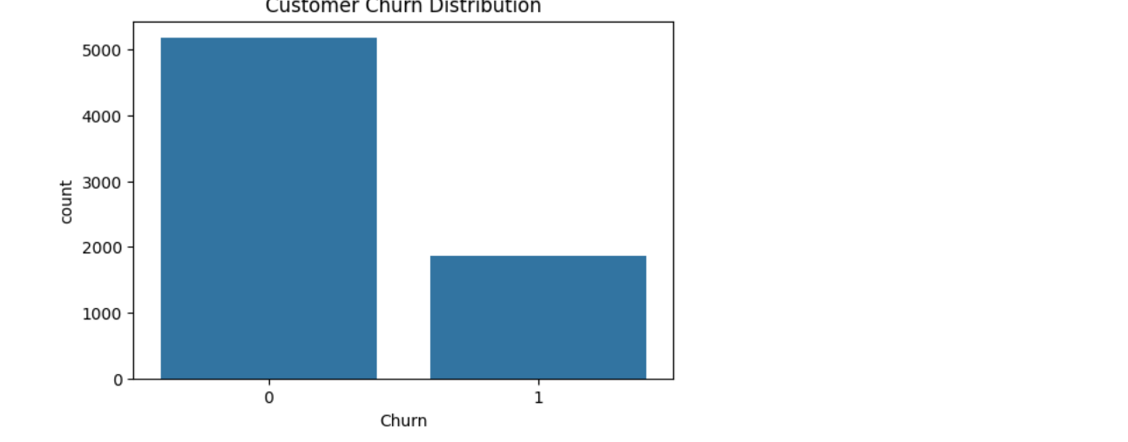
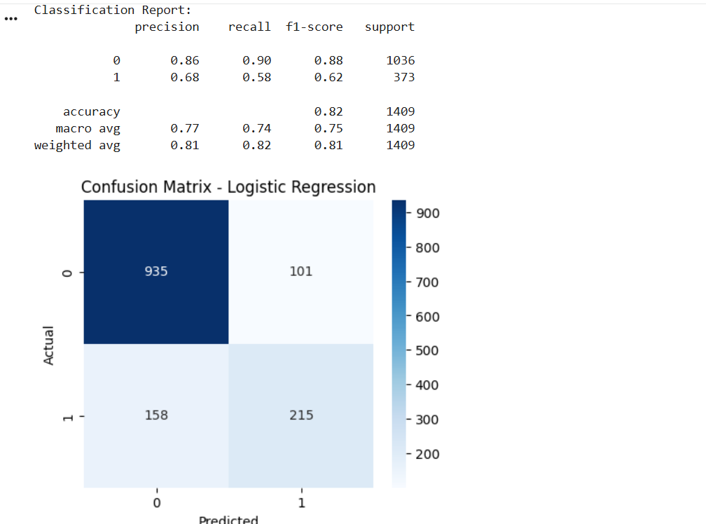
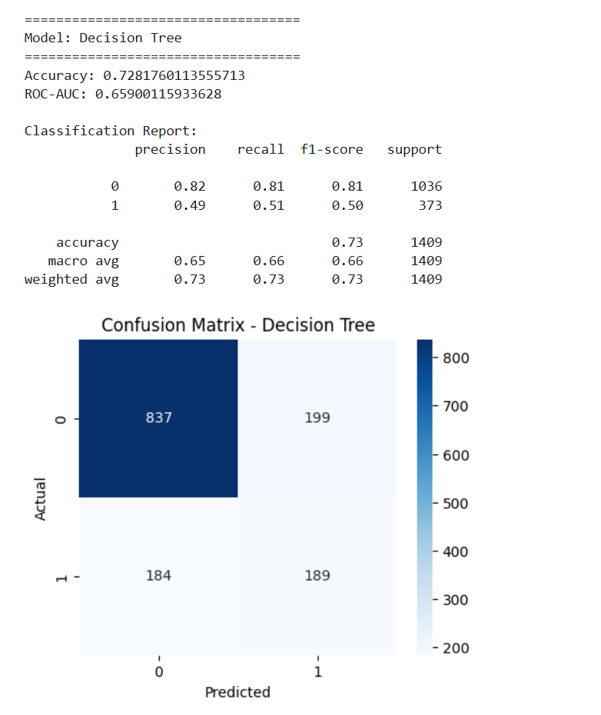
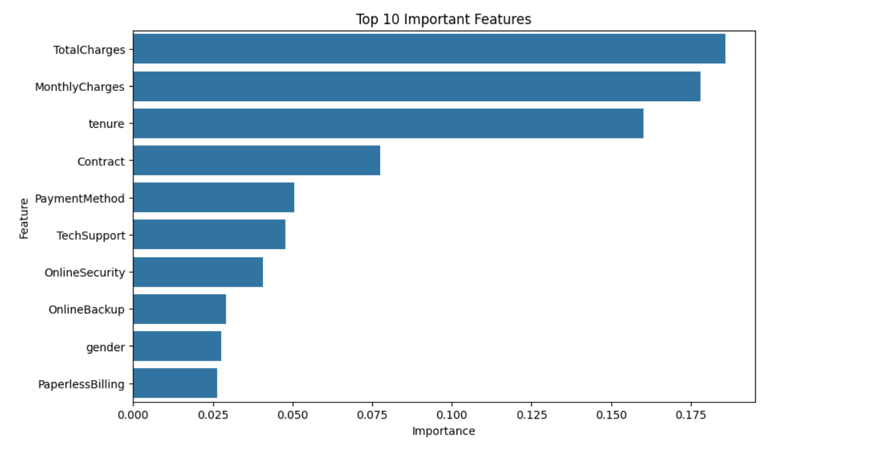
Conclusion
The study was able to implement the supervised machine learning technique in predicting telecom customer churn with the Telco Customer Churn dataset. To find the most appropriate predictive model, several machine learning algorithms including Logistic Regression, Decision Tree, Random Forest and Support Vector Machine (SVM) were implemented and evaluated. All models were compared, the result showed that Logistic Regression obtained the best predictive performance with an accuracy of 81.62% and ROC-AUC of 86.15% compared to all other models. Random Forest also performed well on the prediction but did not perform as well when it came to identifying churn customers. However, Decision Tree and SVM models did not perform as well as the others. The findings suggest that machine learning can provide valuable insights for telecommunications firms to help them determine when their customers are likely to churn, allowing businesses to take proactive action to retain those customers and maintain their profitability. Advanced ensemble learning techniques, feature engineering and approaches to address class imbalance are possible areas for future research to further improve predictive accuracy for churn.

